**Project 1**

**<Blackjack>**

**Alexis Naranjo**

**11/7/18**

**CSC-5 47993**

**Introduction**

Title: Blackjack

The game is blackjack and requires the player to beat the dealer. The player can do this by holding on to a hand equal to or less than 21 and a hand that forces the dealer to bust or go over 21. The player can also lose if the player bust by going over 21 or if the dealer matches or beats the players hand. In this game of blackjack, it will utilize numbers from 1 to 11 to represent the cards the player and the dealer received. The player can win, tie, or lose and win, retain, or lose money depending on the outcome of the game and the amount bet.

**Summary**

Project size: 341 lines

Number of variables: 11

This project demonstrates concepts learned in chapter 2 through 5 in Gaddis 9th edition. The project took 3 days to complete with little trouble being encountered throughout the whole process. The base of the game such as version 1 was created relatively fast, with version 3 also being done rather quickly. Version 3 was the version of the game that I felt happy and complete with and is probably where I would have left it if it wasn’t a project. The most difficult part of the project came with including many of the concepts learned so far during the semester. Deciding where and how to include the concepts is what took me two extra days to complete the project.

**Description**

The main point of this program is to display a game to display all of the concepts learned in the semester so far.

**Flow Chart**

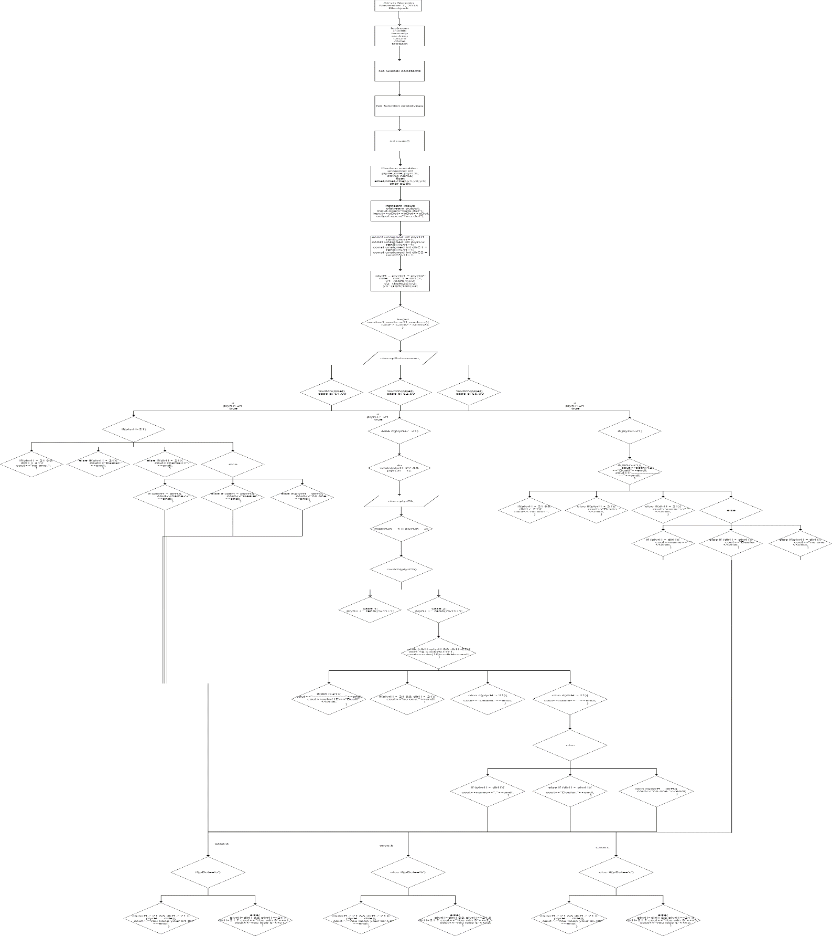

**Pseudo Code**

/*

* File: main.cpp

* Author: Alexis Naranjo

* Created on November 7, 2018, 7:00 PM

* Purpose: BlackJack

*/

//System Libraries

//User Libraries

//Global Constants Physics/Math/Conversions/Array

//Function Prototypes

//Execution begins with main

//Set the random seed.

//Declare Variables

//Opens an input file for bets, and a output file for hits and stands.

//Opens file to display bets at

//$1.00,$2.50,$5.00.

//Map or process the variables to their outputs

//Players first card.

//Players second card.

//Dealers first card.

//Dealers second card.

//Adds Players two cards for hand.

//Adds Dealers two cards for hand.

//Calculates players money win at a

//$1.00 bet.

//Calculates players money win at a

//$2.50 bet.

//Calculates players money win at a

//$5.00 bet.

//Display or return the output

//Displays cards that are in play.

//Shows player what to enter for what bet, and displays bets within file.

//Ask the user to enter a bet and a name to display at the end.

//Displays dealers

//first card.

//Displays players first card.

//Displays players

//second card.

//If players original hand is

//greater than 21 it will

//display bust.

//Will repeatedly ask the user to input 1 or 2 until the user bust

//or user enters 2 to stand.

//User inputs his or her choice to hit with 1 or stand with 2.

//Players hit will be added to their hand.

//If the player doesn't bust with their original

// hand or if the player doesn't bust while

// hitting and decides to stand then

//this set of code is ran.

//Displays dealers first card.

//Displays dealers second card.

//Displays dealers original hand.

//If the players hand is greater than dealers

// original hand it will continue to hit until

//it beats the players hand or it bust.

//Displays a bust for the dealer if it's original

//or new hand is over 21.

//This decides the winner of the game.

//If both the players and the dealers hands

//are over 21 then no one wins.

//If the players hand is greater than 21

//the dealer wins.

//If the dealers hand is greater than 21

//the player wins.

//If none of the above occur then this set is tested.

//If the players hand is greater than

//the dealers hand than the player wins.

//If the dealers hand is greater than

//the players hand than the dealer wins.

//If the players hand is equal to the dealers

//hand then no one wins.

//Displays money return for a bet at $1.00 where

//no one wins.

//Displays money won or loss for a bet at

//$1.00 where no one wins.

//Displays money return for a bet at $2.50 where

//no one wins.

//Displays money won or loss for a bet at

//$2.50 where no one wins.

//Displays money return for a bet at $5.00 where

//no one wins.

//Displays money won or loss for a bet at

//$5.00 where no one wins.

//This allows the code above to run as long as the players hand is

//less than 22.

//If the players new hand is over 21 then the

//code below is ran.

//Code from 244 through 270 runs same as code from 163 through 197.

//Closes files.

**Major Variables**

unsigned int plyrH,dlrH,plyrCh; Shows players hands and dealers hands. Allows the player to choose hit or stand.

string name; Allows the name of the player.

float aBet,bBet,cBet,y1,y2,y3; Calculates and displays the players bet.

char pBet; Allows player to enter a,b, or c.

**References**

Gaddis 9th Ed

**Code/Program**

/*

* File: main.cpp

* Author: Alexis Naranjo

* Created on November 7, 2018, 7:00 PM

* Purpose: BlackJack

*/

//System Libraries

#include <iostream>

#include <cstdlib>

#include <iomanip>

#include <cstring>

#include <cmath>

#include <ctime>

#include <fstream>

using namespace std;

//User Libraries

//Global Constants Physics/Math/Conversions/Array

//Function Prototypes

//Execution begins with main

int main(int argc, char** argv) {

//Set the random seed.

srand(static_cast<unsigned int>(time(0)));

//Declare Variables

unsigned int plyrH,dlrH,plyrCh;

string name;

float aBet,bBet,cBet,y1,y2,y3;

char pBet;

//Opens an input file for bets, and a output file for hits and stands.

ifstream input;

ofstream output;

input.open("bets.dat"); //Opens file to display bets at

input>>aBet>>bBet>>cBet; //$1.00,$2.50,$5.00.

output.open("hns.dat");

//Map or process the variables to their outputs

const unsigned int plyrC1 = rand()%11+1;//Players first card.

const unsigned int plyrC2 = rand()%11+1;//Players second card.

const unsigned int dlrC1 = rand()%11+1; //Dealers first card.

const unsigned int dlrC2 = rand()%11+1; //Dealers second card.

plyrH = plyrC1 + plyrC2; //Adds Players two cards for hand.

dlrH = dlrC1 + dlrC2; //Adds Dealers two cards for hand.

y1=(sqrt(4))/2; //Calculates players money win at a

//$1.00 bet.

y2=(sqrt(25))/2; //Calculates players money win at a

//$2.50 bet.

y3=(sqrt(100))/2; //Calculates players money win at a

//$5.00 bet.

//Display or return the output

cout<<"This game of blackjack will choose from this set of numbers."<<endl;

for(int cards=1;cards<=11;cards++){ //Displays cards that are in play.

cout<<cards<<setw(3);

}

cout<<endl;

//Shows player what to enter for what bet, and displays bets within file.

cout<<fixed<<setprecision(2)<<"Enter a for a $"<<aBet<<"."<<endl;

cout<<fixed<<setprecision(2)<<"Enter b for a $"<<bBet<<"."<<endl;

cout<<fixed<<setprecision(2)<<"Enter c for a $"<<cBet<<"."<<endl;

cout<<"Please enter a bet and a name for yourself."<<endl;

//Ask the user to enter a bet and a name to display at the end.

cin>>pBet>>name;

switch(pBet){

case 'a':cout<<fixed<<setprecision(2)<<"$"<<aBet

<<" bet entered."<<endl;break;

case 'b':cout<<fixed<<setprecision(2)<<"$"<<bBet

<<" bet entered."<<endl;break;

case 'c':cout<<fixed<<setprecision(2)<<"$"<<cBet

<<" bet entered."<<endl;break;

}

cout<<"Dealers first card"<<endl;

cout<<setw(10)<<static_cast<int>(dlrC1)<<endl; //Displays dealers

//first card.

cout<<"---------------------"<<endl;

cout<<setw(14)<<"Your Hand"<<endl;

cout<<setw(8)<<static_cast<int>(plyrC1); //Displays players first card.

cout<<setw(4)<<static_cast<int>(plyrC2)<<endl;//Displays players

//second card.

if(plyrH>21){ //If players original hand is

cout<<"---------------------"<<endl; //greater than 21 it will

cout<<setw(12)<<"Bust!"<<endl; //display bust.

cout<<"---------------------"<<endl;

cout<<setw(8)<<dlrC1;

cout<<setw(4)<<static_cast<int>(dlrC2)<<endl;

cout<<setw(10)<<static_cast<int>(dlrH)<<endl;

cout<<"Winner is ";

if(plyrH > 21 && dlrH > 21){

cout<<"no one.";

}

else if(plyrH > 21){

cout<<"Dealer."<<endl;

}

else if(dlrH > 21){

cout<<name<<"."<<endl;

}

else{

if (plyrH > dlrH){

cout<<name<<"."<<endl;

}

else if (dlrH > plyrH){

cout<<"Dealer."<<endl;

}

else if(plyrH = dlrH){

cout<<"no one."<<endl;

}

}

if(pBet=='a'){

if(plyrH > 21 && dlrH > 21 || plyrH == dlrH){

cout<<"You keep your $1.00"<<endl;

}

else{

plyrH>dlrH && plyrH<=21 || dlrH>21 ? cout<<"You win $"<<y1 :

cout<<"You lose $"<<y1;

}

}

else if(pBet=='b'){

if(plyrH > 21 && dlrH > 21 || plyrH == dlrH){

cout<<"You keep your $2.50"<<endl;

}

else{

plyrH>dlrH && plyrH<=21 || dlrH>21 ? cout<<"You win $"<<y2 :

cout<<"You lose $"<<y2;

}

}

else if(pBet=='c'){

if(plyrH > 21 && dlrH > 21 || plyrH == dlrH){

cout<<"You keep your $5.00"<<endl;

}

else{

plyrH>dlrH && plyrH<=21 || dlrH>21 ? cout<<"You win $"<<y3 :

cout<<"You lose $"<<y3;

}

}

}

else if(plyrH<=21){

cout<<setw(10)<<static_cast<int>(plyrH)<<endl;

cout<<"---------------------"<<endl;

cout<<"Enter 1 to hit or enter 2 to stand."<<endl;

cout<<"Your hand is "<<plyrH<<endl;

cout<<"---------------------"<<endl;

//Will repeatedly ask the user to input 1 or 2 until the user bust

//or user enters 2 to stand.

do {

//User inputs his or her choice to hit with 1 or stand with 2.

cin>>plyrCh;

output<<plyrCh<<endl;

if(plyrCh==1 || plyrCh==2){

switch(plyrCh){

case 1://Players hit will be added to their hand.

plyrH += rand()%11+1;

cout<<"Your hand is "<<plyrH<<endl;

cout<<"Enter 1 to hit or enter 2 to stand."<<endl;

cout<<"---------------------"<<endl;break;

case 2://If the player doesn't bust with their original

// hand or if the player doesn't bust while

// hitting and decides to stand then

//this set of code is ran.

cout<<setw(15)<<"Dealers Hand"<<endl;

//Displays dealers first card.

cout<<setw(8)<<dlrC1;

//Displays dealers second card.

cout<<setw(4)<<static_cast<int>(dlrC2)<<endl;

//Displays dealers original hand.

cout<<setw(10)<<static_cast<int>(dlrH)<<endl;

//If the players hand is greater than dealers

// original hand it will continue to hit until

//it beats the players hand or it bust.

while(dlrH<plyrH && dlrH<22){

dlrH += rand()%11+1;

cout<<setw(10)<<dlrH<<endl;

}

//Displays a bust for the dealer if it's original

//or new hand is over 21.

if(dlrH>21){

cout<<"---------------------"<<endl;

cout<<setw(12)<<"Bust!"<<endl;

}

cout<<"---------------------"<<endl;

//This decides the winner of the game.

cout<<setw(4)<<"Winner is ";

//If both the players and the dealers hands

//are over 21 then no one wins.

if(plyrH > 21 && dlrH > 21){

cout<<"no one."<<endl;

}

//If the players hand is greater than 21

//the dealer wins.

else if(plyrH > 21){

cout<<"Dealer."<<endl;

}

//If the dealers hand is greater than 21

//the player wins.

else if(dlrH > 21){

cout<<name<<"."<<endl;

}

//If none of the above occur then this set is tested.

else{

//If the players hand is greater than

//the dealers hand than the player wins.

if (plyrH > dlrH){

cout<<name<<"."<<endl;

}

//If the dealers hand is greater than

//the players hand than the dealer wins.

else if (dlrH > plyrH){

cout<<"Dealer."<<endl;

}

//If the players hand is equal to the dealers

//hand then no one wins.

else if(plyrH = dlrH){

cout<<"no one."<<endl;

}

}

//Displays money return for a bet at $1.00 where

//no one wins.

if(pBet=='a'){

if(plyrH > 21 && dlrH > 21 || plyrH == dlrH){

cout<<"You keep your $1.00"<<endl;

}

//Displays money won or loss for a bet at

//$1.00 where no one wins.

else{

plyrH>dlrH && plyrH<=21 || dlrH>21 ?

cout<<"You win $"<<y1 : cout<<"You lose $"<<y1;

}

}

//Displays money return for a bet at $2.50 where

//no one wins.

else if(pBet=='b'){

if(plyrH > 21 && dlrH > 21 || plyrH == dlrH){

cout<<"You keep your $2.50"<<endl;

}

//Displays money won or loss for a bet at

//$2.50 where no one wins.

else{

plyrH>dlrH && plyrH<=21 || dlrH>21 ?

cout<<"You win $"<<y2 : cout<<"You lose $"<<y2;

}

}

//Displays money return for a bet at $5.00 where

//no one wins.

else if(pBet=='c'){

if(plyrH > 21 && dlrH > 21 || plyrH == dlrH){

cout<<"You keep your $5.00"<<endl;

}

//Displays money won or loss for a bet at

//$5.00 where no one wins.

else{

plyrH>dlrH && plyrH<=21 || dlrH>21 ?

cout<<"You win $"<<y3 : cout<<"You lose $"<<y3;

}

}break;

}

}

else{

cout<<"Invalid input, try again."<<endl;

cout<<"Enter 1 to hit or enter 2 to stand."<<endl;

}

}

//This allows the code above to run as long as the players hand is

//less than 22.

while(plyrH<22 && plyrCh==1);

}

if(plyrH>21){

//If the players new hand is over 21 then the

//code below is ran.

cout<<setw(12)<<"Bust!"<<endl;

cout<<"---------------------"<<endl;

cout<<setw(15)<<"Dealers Hand"<<endl;

cout<<setw(8)<<dlrC1;

cout<<setw(4)<<static_cast<int>(dlrC2)<<endl;

cout<<"---------------------"<<endl;

if(dlrH>21){

cout<<setw(12)<<"Bust!"<<endl;

cout<<"---------------------"<<endl;

}

cout<<setw(10)<<static_cast<int>(dlrH)<<endl;

cout<<"Winner is ";

if(plyrH > 21 && dlrH > 21){

cout<<"no one.";

}

else if(plyrH > 21){

cout<<"Dealer."<<endl;

}

else if(dlrH > 21){

cout<<name<<"."<<endl;

}

else{

if (plyrH > dlrH){

cout<<name<<"."<<endl;

}

else if (dlrH > plyrH){

cout<<"Dealer."<<endl;

}

else if(plyrH = dlrH){

cout<<"no one."<<endl;

}

}

//Code from 244 through 270 runs same as code from 163 through 197.

if(pBet=='a'){

if(plyrH > 21 && dlrH > 21 || plyrH == dlrH){

cout<<"You keep your $1.00"<<endl;

}

else{

plyrH>dlrH && plyrH<=21 || dlrH>21 ? cout<<"You win $"<<y1 :

cout<<"You lose $"<<y1;

}

}

else if(pBet=='b'){

if(plyrH > 21 && dlrH > 21 || plyrH == dlrH){

cout<<"You keep your $2.50"<<endl;

}

else{

plyrH>dlrH && plyrH<=21 || dlrH>21 ? cout<<"You win $"<<y2 :

cout<<"You lose $"<<y2;

}

}

else if(pBet=='c'){

if(plyrH > 21 && dlrH > 21 || plyrH == dlrH){

cout<<"You keep your $5.00"<<endl;

}

else{

plyrH>dlrH && plyrH<=21 || dlrH>21 ? cout<<"You win $"<<y3 :

cout<<"You lose $"<<y3;

}

}

}

//Closes files.

input.close();

output.close();

return 0;

}